WorkBC Wage

Subsidy
EMPLOYER
GUIDE

January 2024



Ministry of Social Development and Poverty Reduction

CONTENTS
1 OVERVIEW 2
WorkBC Wage Subsidy Program 2
2 WAGE SUBSIDY RATES 3
3 ELIGIBILITY CRITERIA 4
Job Seeker Eligibility 4
Employer Eligibility 4
Questions and Answers 6
4 APPLICATION 8
How do I apply? 8
What information do I need for the application? 8
5 WAGE SUBSIDY PLATFORM INSTRUCTIONS 9
Overview 9
Access 9
How do I submit a claim form? 10
How do I share applications or claim forms with others? 12
Can I filter or sort my applications and claim forms for easier viewing? 14
How do I update my contact information that is pre-filled on subsequent applications and claim forms? 14
6 CONTACT US 16

OVERVIEW

WorkBC Wage Subsidy Program
The WorkBC Wage Subsidy program covers a portion of the employee wages in exchange for on-the-job training and work experience.

Program benefits for employers:
  - Reduced cost of hiring and training a new employee
  - Coverage of a portion of employee wages
  - Fill vacant positions
  - Disability supports to reduce work-related barriers for an employee

Program benefits for job seekers:
- Paid work experience opportunities
- On-the-job training
- Possible long-term employment options

WorkBC Centres administer the program and can:
- Tell you more about the program
- Help you with your application
- Match you with a suitable candidate

Find your local WorkBC Centre

Here is some basic information to help you decide if the WorkBC Wage Subsidy is right for you:
- Jobs need to be primarily based and performed in B.C.
- Jobs need to be a full-time position of 35-40 hours (exceptions may apply)
- You cannot lay off or terminate an employee to access Wage Subsidy
- You cannot fill a vacant position caused by a layoff (unless that employee declines the position).

WAGE SUBSIDY RATES

The wage subsidy duration and rate will be based on the amount of work experience and on-the-job training the client requires to perform the position.

Wage Subsidy Rates for WorkBC and Priority Clients
Client Type | Duration | First Eight weeks | Second Eight weeks | Final Eight weeks
Wor​kBC Clients | Up to 24 weeks | 50%  (up to $500 weekly) | 25%  (up to $250 weekly) | 15%  (up to $150 weekly)
Priority Clients  Youth (16-30) and individuals with disabilities | Up to 24 weeks | 75%  (up to $750 weekly) | 50%  (up to $500 weekly) | 25%  (up to $250 weekly)

Wage Subsidy Rates for Custom Category Clients
Client Type | Duration | First 26 weeks | Second 26 weeks | Final 26 weeks
Custom Category Clients  (WorkBC-matched people with disabilities or complex barriers to employment) | Up to 78 weeks | Negotiated percentage, up to the weekly maximum amount (cannot exceed 85%)

ELIGIBILITY CRITERIA

Job Seeker Eligibility
A job seeker must be:
  - A B.C. permanent resident or Canadian Citizen
  - Unemployed (not working full-time, part- time, temporarily, etc.)
  - Identified for this service through a WorkBC service provider or employer
  - In need of work experience

Employer Eligibility
An employer must:
  - Be a registered business in B.C.
  - Comply with all applicable legislation including, but not limited to, the Employment Standards Act, Workers Compensation Act, Income Tax Act (Canada) and the Employment Insurance Act (Canada)
  - Be at Arm’s Length from the WorkBC service provider and employee
  - Offer a full-time position of approximately 35-40 hours per week, unless the Job seeker has a documented need for fewer hours per week
  - Offer Insurable Employment
  - Offer a position where the job and work are primarily done in B.C.
  - Not fill a position vacant because of layoff (other than by filling it with the laid-off person, unless that person declines the position)
  - Confirm that the jobseeker is not an existing employee unless they have been laid-off and are being recalled
  - Confirm the jobseeker would not be hired in the absence of a Wage Subsidy
  - Confirm that as a result of the Wage Subsidy placement, no workers will experience reduction in hours or be laid-off
  - Offer the likelihood of long-term employment or provide needed work experience to help the jobseeker achieve long-term employment elsewhere
  - Pay reasonable, competitive wages reflecting the prevailing wage rate for the position

An employer must not:
- Be either the Government of B.C. or Government of Canada
- Be considered public sector, including municipalities, schools, school boards, public universities and colleges, hospitals, health authorities or “other government entities”
  - For Wage Subsidy policy, the definition of “other
government entities” does not include businesses and corporations owned and/or controlled by Indigenous-governing bodies
- Lay off or terminate an employee for the purposes of accessing a Wage Subsidy
- Offer employment based on 100% commission or piecework. The Jobseeker must be paid a guaranteed labour market wage in addition to any commission-based earnings
- Be an active WorkBC client participating in Self-Employment Services
- Offer a position working under a WorkBC contract
- Be the WorkBC service provider that provides the Wage Subsidy
- Be in receipt of other Wage Subsidy funding for the jobseeker WorkBC will be subsidizing during the same period
NOTE: Employers applying for Wage Subsidy are required to digitally attest that they are in full compliance with the program requirements outlined above

Questions and Answers

What does it mean to be “at arm’s length”?
Arm’s length means two parties (individuals or organizations) who are not related. Related persons are individuals who are family by blood, marriage, common law partnership or adoption.

Is the WorkBC Wage Subsidy Program only available for B.C. jobs?
Yes, all individuals subsidized under a WorkBC Wage Subsidy must be in a position where the job and work are primarily done in B.C.

Can I receive other Wage Subsidy funding and the WorkBC Wage Subsidy for the same employee?
You cannot receive the Canada Recovery Hiring Program, Tourism and Hospitality Recovery Program, Hardest-Hit Business Recovery Program, or other Wage Subsidy funding for the same WorkBC client at the same time.

What is the maximum number of subsidies an employer is eligible for?
An employer can have up to five active Wage Subsidy agreements per CRA Business Number at one time and a maximum of 10 subsidized clients per fiscal year (April - March).

Can I access WorkBC Wage Subsidy for any job seeker who is underemployed?
Employees who are underemployed (employed below their level of education or on a part-time basis) are not eligible for a Wage Subsidy. However, they are encouraged to contact their local WorkBC Centre to enquire about services and supports that might be available to help them achieve full-time employment.

Can employers recall employees who were laid-off?

Yes, an employer can rehire someone who was previously laid off - but cannot lay off or terminate someone for the purpose of accessing the subsidy.

Can I provide a wage subsidy that is less than 35 hours per week?
The 35 hours per week requirement is approximate. The intent of WorkBC Wage Subsidy is to support full-time placements. Job seekers who require less than a full-time Wage Subsidy must contact their WorkBC Centre (these clients must be Case-Managed Clients who are matched through a WorkBC Centre).

How do employers select an employee for Wage Subsidy?

There are two ways to select an employee for your Wage Subsidy position:
- Ask WorkBC to send you candidates (‘WorkBC Match”)
- Identify a candidate from your own pool of applicants (“Employer Identified”)
  - These job seekers will need to register with WorkBC Self-Serve using the Online Employment Services portal

How does my identified job seeker register?
When you submit your application, include an identified individual’s email. They will
receive an email outlining the next steps.

What financial supports is an employer eligible for?
Employers may be eligible for supports, such as:
  - Some of the employee’s wages (See Wage Subsidy Rates in Section 2)
  - Employer portion of the Mandatory Employment Related Costs (MERCs)- EI, CPP, WorkSafeBC, Vacation Pay
  - Disability supports to reduce barriers for an employee to work

APPLICATION

How do I apply?
There are two ways to apply:

- Use an easy online application form (accessed within the WorkBC Wage Subsidy platform)

Contact a WorkBC Centre

WorkBC Centres administer the wage subsidy program, they can:
  - Tell you more about the program
  - Help you with your application
  - Match you with a qualified job seeker

What information do I need for the application?
You will need a BCeID (Business or Basic) to access the online Wage Subsidy platform.
Once you initiate a new application, you will need to provide some basic information about your business, such as contact information, address and your CRA Business Number. You will answer questions such as:
  - Do you have third-party liability coverage?
  - Do you have WorkSafeBC coverage?
  - Do you meet the eligibility criteria?
It takes about 10 minutes to complete the application. You will be able to save a temporary copy (“Draft”) of your application on the Wage Subsidy platform and submit it later. Your WorkBC Centre will contact you for any follow-up required.
If you have an identified job seeker in mind, you will need to submit their email address in your application as well.
If you have a position available but have not identified an employee, you can apply to be matched to a qualified, job-ready candidate. WorkBC will inform you about the next steps in the application process once you have applied.

WAGE SUBSIDY PLATFORM INSTRUCTIONS

Overview

The Wage Subsidy platform is a tool to submit applications and claim forms for the WorkBC Wage Subsidy program. You can:
- View a record of current and past applications and claim forms
- See real-time status updates for applications and claim forms
- Share applications and claim forms with others in your organization (Business BCeID only)

Access

You will require either a Business BCeID or a Basic BCeID to log in to the Wage Subsidy platform.

Business BCeID

Use a Business BCeID if you would like to submit, view and share applications and claim forms within your organization.
If you are starting a new Business BCeID registration, it can take some time to verify your business if it is not already registered with BC Registries and Online Services. If time is an issue, set up Basic BCeID now and convert it to Business BCeID later.

If your organization already has a Business BCeID account, talk to your account administrator to ensure you have a user account. This can be done under the organization’s overall account.

Basic BCeID
With a Basic BCeID, you will be able to log in to the platform to submit and view your own applications and claim forms. You will not be able to share applications and claim forms with others with this type of BCeID.

For more information and Frequently Asked Questions, visit www.bceid.ca.

Employer Login

Once you have your BCeID, click the Employer Login button from the Wage Subsidy home page.

Upon successful login, you can initiate a new application (Figure 1) or view the main applications list page, if you have at least one existing application (Figure 2).

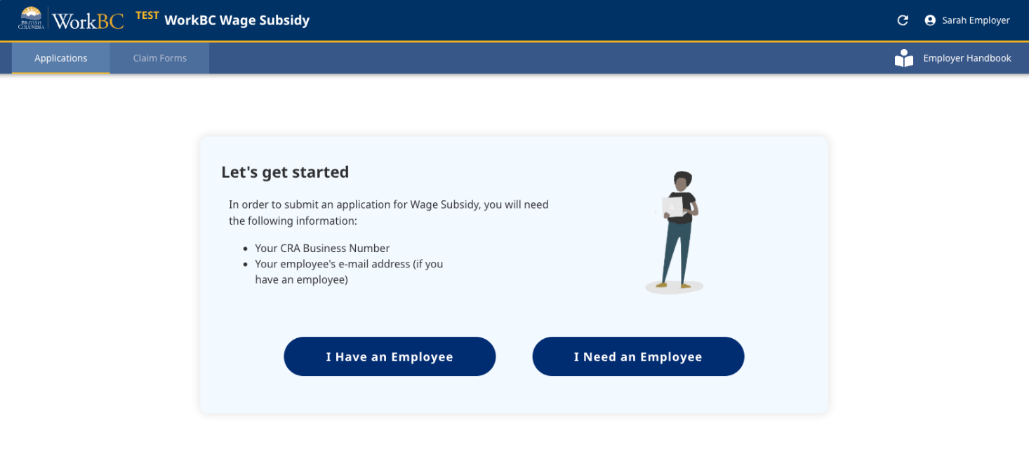
Figure 1: New application launch view

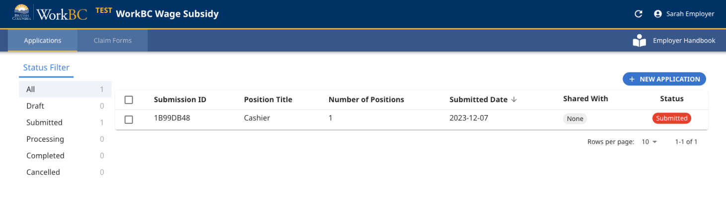
Figure 2: Applications list view

How do I submit a claim form?

Once you have an active Wage Subsidy agreement in place, you can submit a claim form in the Wage Subsidy platform (Figure 3), by selecting your Completed application (Figure 4). You will only see completed applications that have been processed on the Wage Subsidy platform.

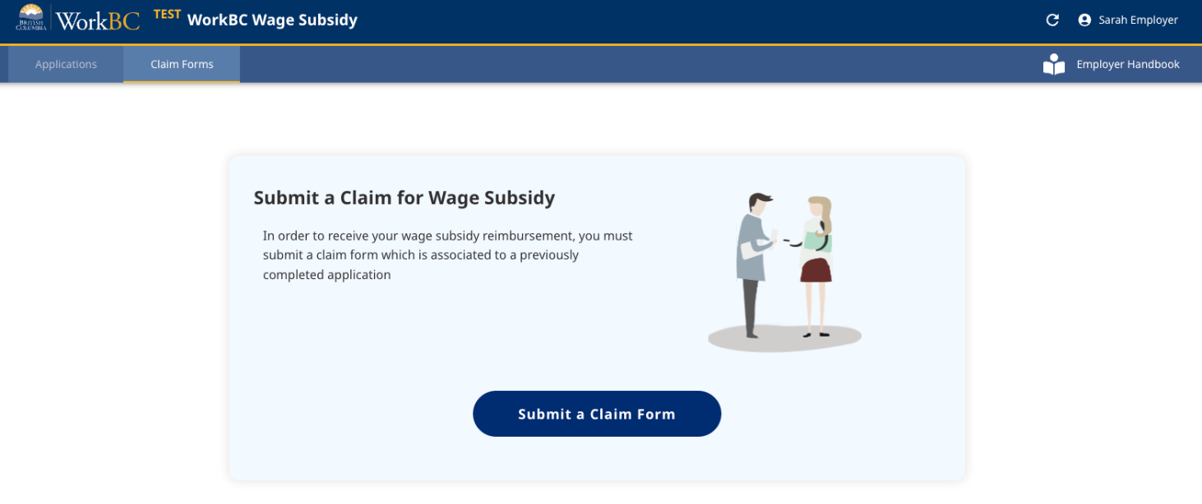
Figure 3: Submit new claim form
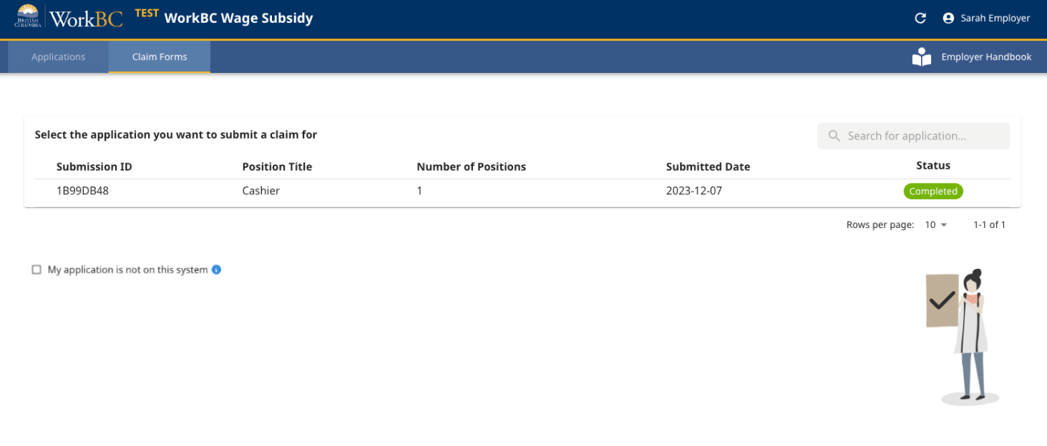
Figure 4: Select Completed application to associate to claim form
If you submitted your application prior to the new Wage Subsidy platform, or if you submitted your application in another form (e.g. by paper or email), select the checkbox next to “My application is not on this system.” This action will enable some additional required fields to enter and validate your business address (Figure 5).

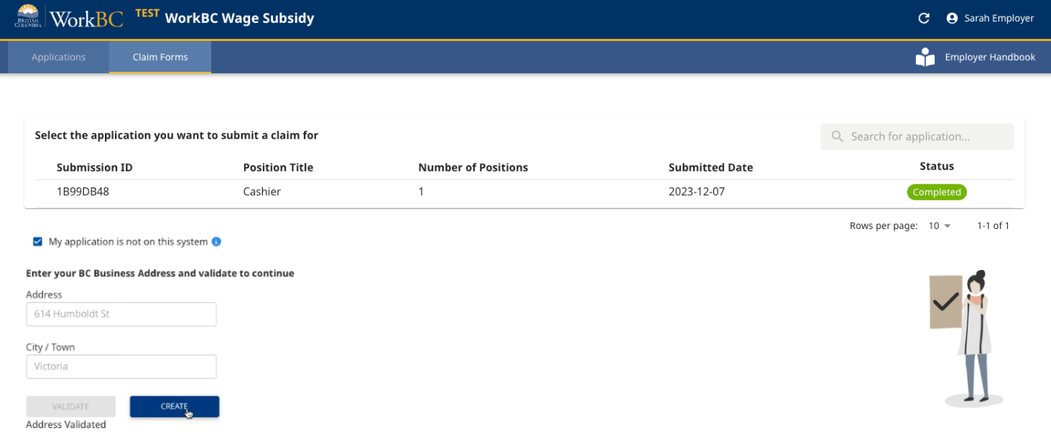
Figure 5: Option to indicate that application is not on the Wage Subsidy platform

Once your claim form is initiated, you will be required to provide the following information:

- Claim period timeframe
- Employee name
- Paystub information
- Mandatory Employment Related Costs (MERCs), such as EI, CPP, WorkSafeBC and eligible vacation pay
- Job activity summary
- Certification that the information being submitted is correct and aligned with the WorkBC Wage Subsidy Agreement in place
- Supporting documentation (such as paystubs) attached in PDF format

You will be able to save a temporary copy (“Draft”) of your claim form on the Wage Subsidy platform and submit it later if needed. Once submitted, your WorkBC Centre will contact you for any follow-up required.

How do I share applications or claim forms with others?
You can share applications and claim forms with others in your Business BCeID organization; Basic BCeID users are not able to share forms.
To share one or more forms, click on the checkbox(es) next to the forms you want to share (step a), then click the ‘SHARE’ link (step b). (See Figure 6).
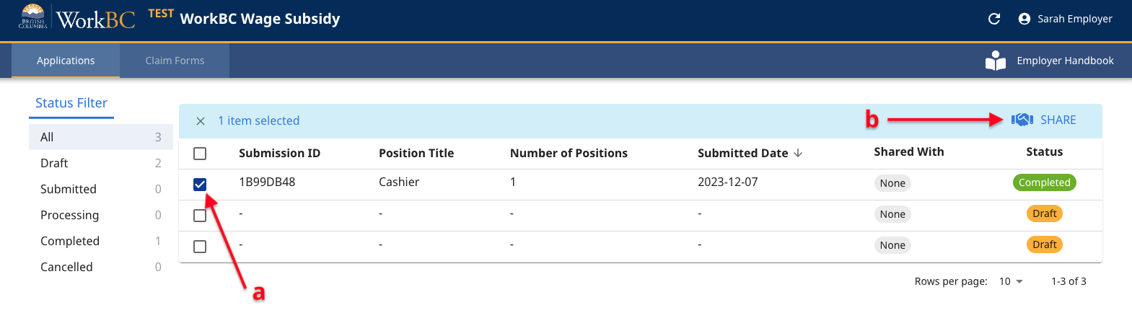
Figure 6: Initiate ‘Share’ of form with others in your organization

In the resulting screen, you will see a list of others in your organization you are able to share your form(s) with. Only individuals who have logged into the Wage Subsidy platform will be listed. Select one or more users (step a) and use the chevron button ‘>’ (step b) to move those users to the ‘Selected’ section, then click the ‘OK’ link (step c). (See Figure 7).

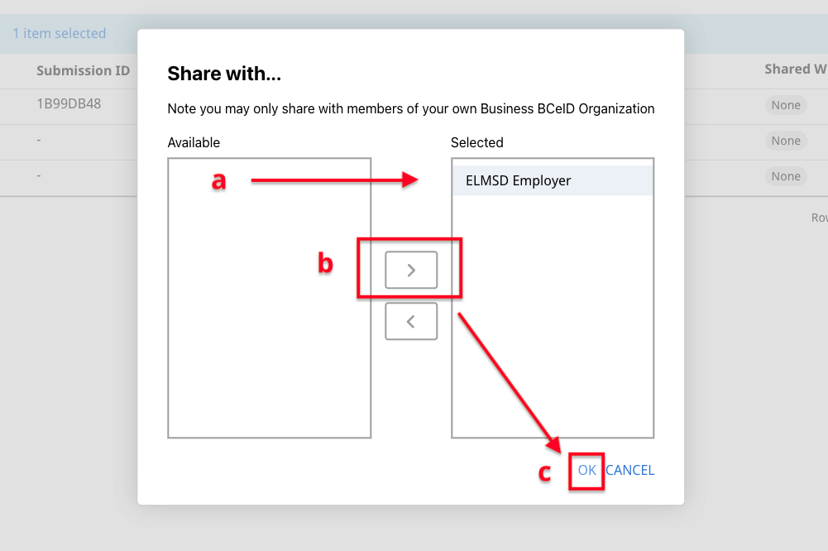
Figure 7: Select users in your organization to share form(s) with

Those individuals the forms are shared with will be listed on the main applications and/or claim forms list pages (Figure 8).
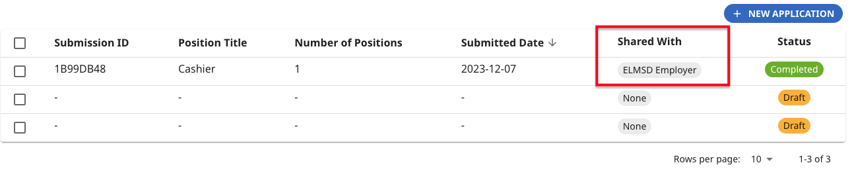
Figure 8: ‘Shared With’ column indicates who forms have been shared with

Can I filter or sort my applications and claim forms for easier viewing?

Yes. To filter your applications and claim forms by status, you can click on a status in the left-hand Status Filter panel (step a). To sort, click on one of the header fields for the given applications or claim forms list (step b). (See Figure 9).

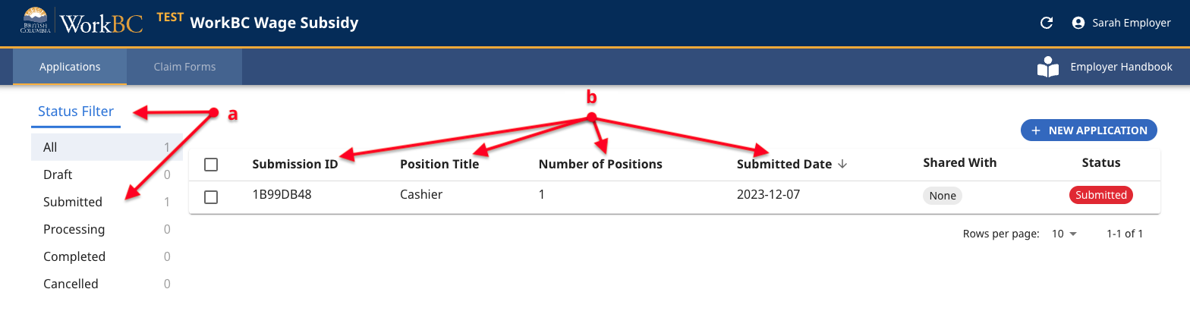
Figure 9: Filter and Sort options

How do I update my contact information that is pre-filled on subsequent applications and claim forms?

After you submit your first application, the following pieces of information are saved to your profile for ease of future form entry:
- Employer (Business) Name
- Contact
- Phone Number
- Fax Number
- Email address
- CRA business number
- Address
- Workplace Address (if different from Address above)

Any new forms you initiate will use these saved values.

If you want to view or update your saved information, click on your name in the top-level navigation bar (step a), then click ‘Edit Profile’(step b). (See Figure 10).

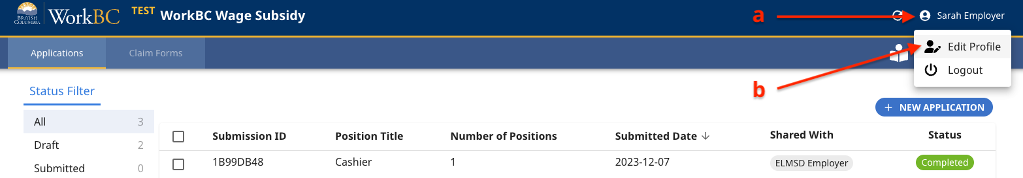
Figure 10: How to access ‘Edit Profile’
You can update your information in the resulting ‘Edit Profile’ window (Figure 11).

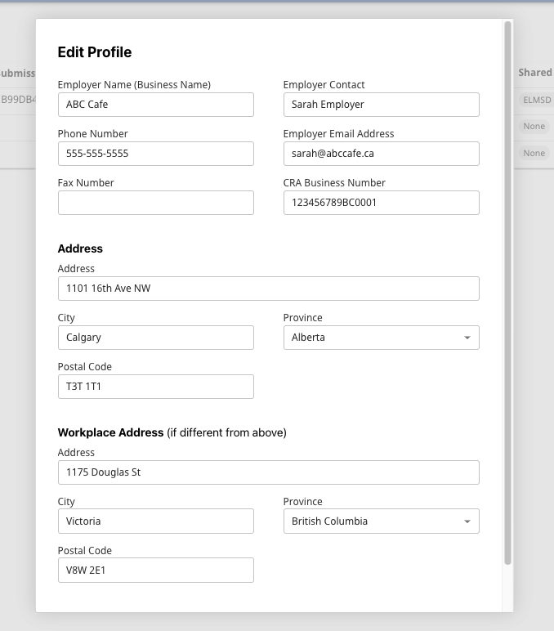
Figure 11: 'Edit Profile' window

CONTACT US
You can contact your local WorkBC Centre for additional information or help completing your application.

Find your local WorkBC Centre

